**Indian Ocean Fury #1 – Persian Pounce**

**AAR by stonie, Nov 2020**

This is a CLASSIFIED: TOP SECRET On Going Action Report (OGAR) from the Persian Gulf. It is the 13th of February 1994 18:00:00 local time. We have just arrived to support the command group overseeing the Gulf given the current circumstance. It looks like the next 2 days might be historic. God forbid not! Or 'Inshallah - God willing' as the locals say. For war seems to have broken out in Europe where the Warsaw Pact has initiated hostilities and there have been attacks reported in the US. Until now things have been quiet in the Gulf, unusually so even. Iran has been unusually quiet and well behaved according to the standard crew running the show the last few weeks.

Mission areas along the Gulf itself are currently well covered by our assets of patrol ships, destroyers, and frigates belonging to NATO in addition to allied ships from Oman, Qatar, Saudi Arabia, UEA, and Kuwait in their respective patrol zones. The Gulf has been segmented into 12 patrol zones ALPHA to LIMA. Battle carrier group with the CV 60 Saratoga Forrestal class patrols outside the entrance of the Gulf and we have access to extensive assets at airbases belonging to our allies along the entire Gulf. To wrap up this SITREP we have been given orders by command as follows.

1. Maintain readiness and vigilance

2. Maintain one Frigate or larger vessel in each of the 12 Patrol Zones marked ALPHA to LIMA

3. Patrol the Straights of Hormuz for mines and any other obstructions to navigation

4. Exit USNS Sgt W.R. Button out of the Gulf (past the Gulf Exit RPS)

5. Protect civilian shipping in the region

6. Maintain diplomatic stability with our Gulf Allies.

Furthermore. If something happens in the Gulf and the Soviets utilize Iranian airspace for attacks we are to avoid provoking the Iranians into the fight. We have enough trouble elsewhere as is. It is worrying already that we already see Warsaw pact ELINT and Maritime surveillance in the air over Iran and some of our assets are reporting electronic interference.

Let's look at the situation.

This is the Gulf outlook right now.

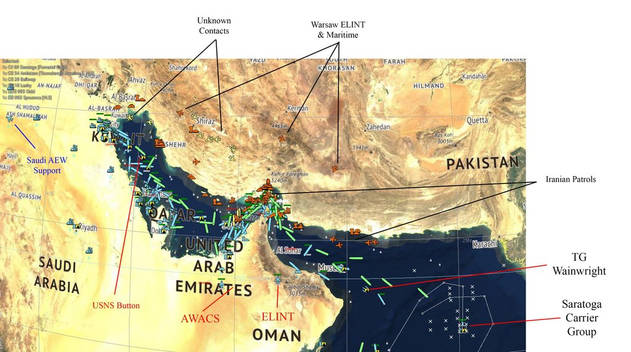

1. Our ally Saudi Arabia is providing AEW support from the North west.

2. Iran has low threat air patrols within its border of control in the Gulf consisting primarily of F-4 phantoms.

3. USNS Sgt W.R Button in tasking group Montgomery is making his way down south to exit the Gulf on a classified mission, he is currently escorted by FF USS Elmer Montgomery.

4. Tasking group Wainwright consisting of Guided Missile Cruisier CG Belknap and Destroyers DD Peterson and DD Elliot will sail from the Gulf entry to rendezvous with TG Montgomery and join the escort out of the Gulf.

5. The rest of our Gulf stationed naval patrolling assets, mainly FFGs, remain on current missions tasked from the previous shift.

6. We have two clusters of unknown air contacts in the vicinity of Al Basrah and Shiraz.

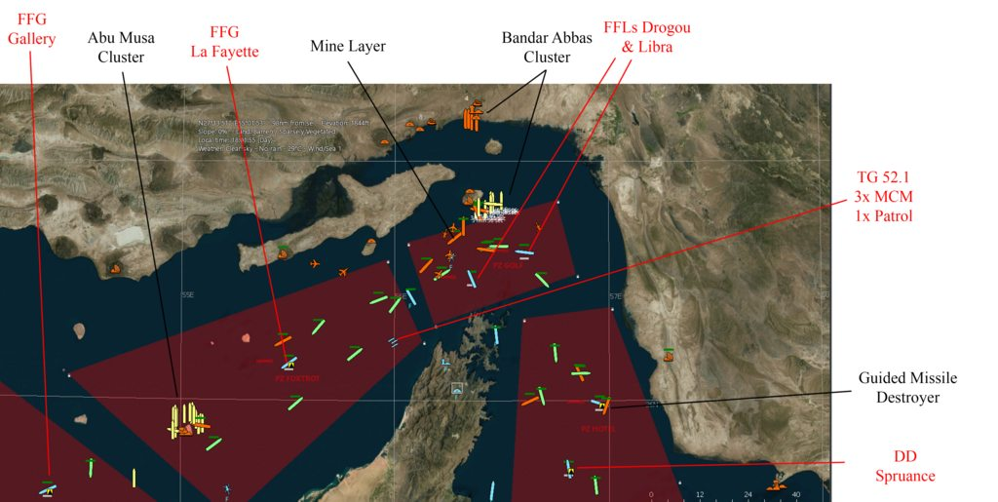

1. Two clusters of unidentified, possibly Iranian warships have been detected in and Southwest of the strait of Hormuz.

2. We currently possess assets in the area more than matching known assets but depending on the contact classification of unknown contacts they might not be a match for the current Iranian assets in the strait.

3. Worryingly an Iranian minelayer is sailing in the strait but our mine countermeasure task group TG 52.1 will arrive presently to observe.

**Assessment**

Our AEW and ELINT is sufficient for now in the North and South of the Gulf but could potentially need to be strengthened in the middle in Qatar if hostilities grow. Our current weakness is that we do not have complete intelligence over potentially hostile assets in the Gulf and an utter lack of air patrols already in the air bordering negligence from the previous shift. Europe is already at war for Christ's sake!

**Command Tasking**

To remedy the situation the command group has decided to schedule the following missions.

**Air Tasking**

1. Send up patrols in the Gulf to intercept and identify unknown air contacts should they become threats to our assets in the Gulf. Air patrols should match the presence of potentially hostile assets and be able to hold back more substantial threats until further aid can be mustered. Five missions have been accepted. Potential threat to aircraft besides air are two SA-5c 'Gammon' SAM located near Bandar Abbas and Bandar Bushehr. They are particularly problematic as if they go HOT they intersect our patrol zones. Particularly vulnerable are PZs Bravo, Charlie, Foxtrot, Golf, and Hotel. Missions have currently been planned to minimize exposure as much as possible.

1. 2x F-16 Block 40 from the 421 FS 'Black Widows' (16x) will take off immediately from Ahmed Al Jaber near Al Jahra in Kuwait and patrol the innermost Gulf PZ ALPHA. Keeping an eye on a suspected 4 ship F-5F Tiger II patrol (presumed Iran). They are particularly vulnerable to Iran SAM SA-5c in Bandar Bushehr. SEAD flight from the Black Widows is ready and on standby in case they are needed.

2. 2x F-16 Block 50 from the 161 FS 'Jayhawks' (12x) will take off immediately from Sheik Isa near Dammam Saudi Arabia to patrol PZ Charlie. They will keep an eye out for incoming contacts from mainland Iran.

3. 2x F-16 Block 40 from 307 FS 'Stingers' (16x) will take off immediately from Al Dhafra near Abu Dhabi UAE to patrol PZ ECHO. They will keep tabs on airspace around Hormuz and assist the Jayhawks if needed. A SEAD flight from the Stingers is on standby for the Hormuz area if needed.

4. 2x F/A-18C Hornet from VFA-82 'Marauders' (12x) shall take off from Saratoga CVBG and station on PZ Kilo. They will keep an eye on a patrolling group of Phantoms from Iran on the Iran - Pakistan border by the Gulf and assist the Stingers at PZ ECHO around Hormuz if needed.

5. 2x F-14B Tomcats from VF-83 'Rampagers' (12x) Saratoga CVBG will provide BARCAP in the vicinity of the carrier TG. They are not to become involved in missions outside of protecting the Saratoga.

2. Two clusters of unidentified surface contacts need to be classified in the Hormuz Strait. One A/C 9-3C Orion set up for Maritime surveillance from the VP-9 'Golden Eagles' (4x) will be dispatched from Masirah airbase Oman to surveil unknown surface contacts in the Gulf from a safe distance.

Air tasking is further visualized here.

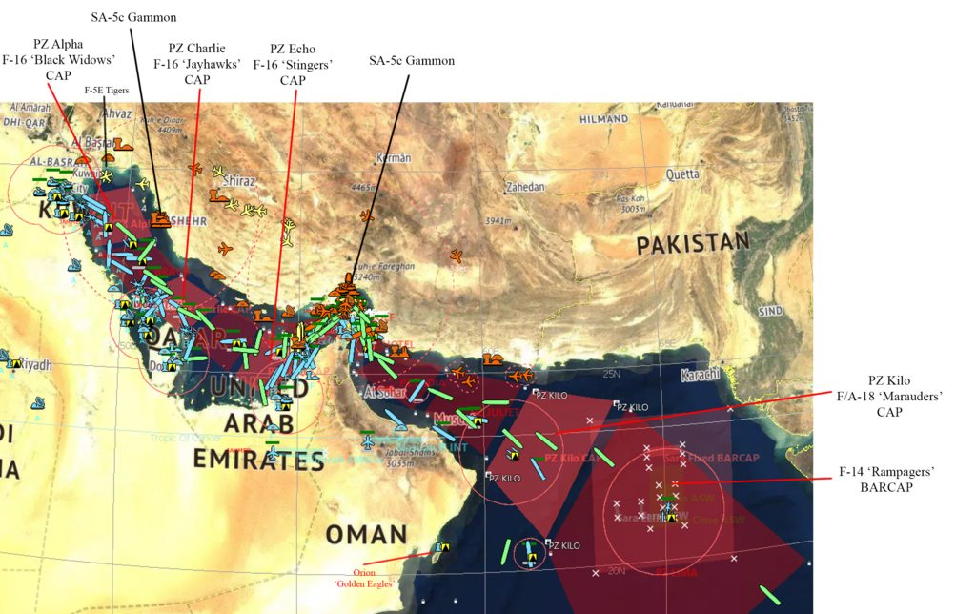

**Naval Tasking**

1. Frigates/Destroyers on standard missions covering all patrol zones.

2. TG Montgomery shall transit to leave the Gulf ASAP but without drawing undue attention.

3. TG Wainwright will transit towards TG Montgomery and rendezvous to join the escort of Button out of the Gulf.

4. TG 52.1 shall observe for potential Iranian minelaying threats in the Hormuz Strait. They have threatened to do it before.

4. CVG Saratoga will patrol the Gulf exit and provide support as needed to assets in the Gulf.

---

Its 18:10:00 local time. Intel reports an increasing number of unknown contacts converging on the gulf. Something might be happening!

Command is going on high alert and has allowed tasking of an immediate response as a precautionary counter stance.

The air tasking order is being modified. In light of the number of contacts and uncertainty of intent two air superiority flights are being added to PZ Bravo and Delta. Across the gulf reserve non fitted A/C are instructed to load up as alarm levels are being raised! We have around 30 unknown contacts converging across the entire gulf! Many of the contacts are indicative of being SU-24 strike craft but a few do not seem to be emitting radar signatures. As a precaution two sections are F-15c eagles have been ordered to support patrols in the gulf.

-A 2 ship flight from F-15C Eagle squadron 27 FS 'Fighting Eagles' will take off from Al Jaber and patrol PZ bravo

-A 2 ship flight from F-15C Eagle squadron 53 FS 'Tigers' will take off from Sheik Isa and patrol PZ Delta.

-A EC-130H from squadron "ECS" from Thumrait Oman is take take off and link up with AWACS in the south and provide offensive ECM in the gulf

No navigation zone has been established by the Iranian coastline to prevent possible mistakes of NATO aircraft triggering an accidental confrontation.

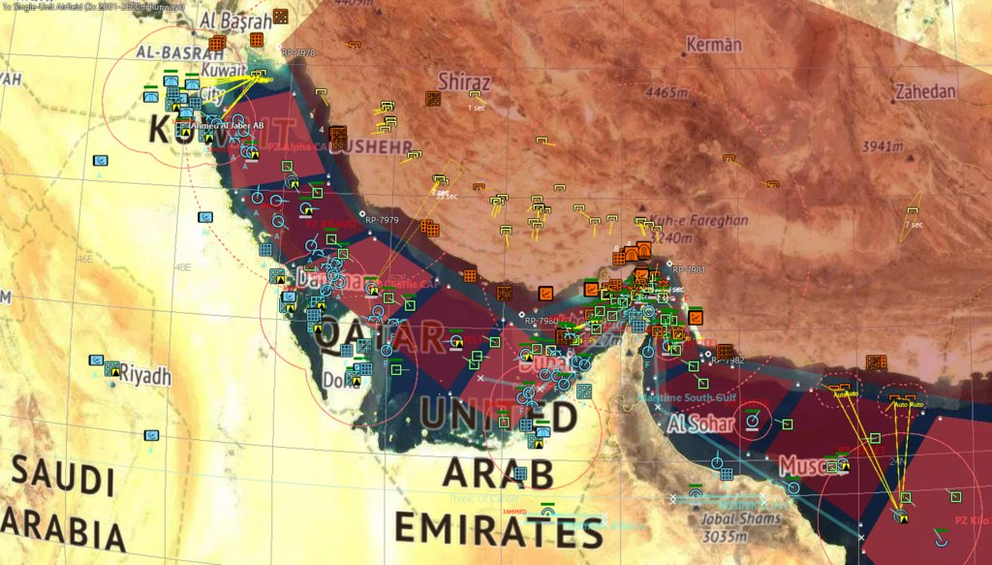

MAXIMUM ALERT! Standoff weapons have been detected from contacts in Iranian airspace! If its the Iranians or Warsaw is currently unknown. Iranian surface contacts in the gulf have shown no signs of hostilities. All squadrons are now to go to maximum alertness and air superiority fighters are to take off immediedly and head into the patrol zones!

The Corvette P 402 ITS Libra is reported hit and sinking in the strait of Hormuz!

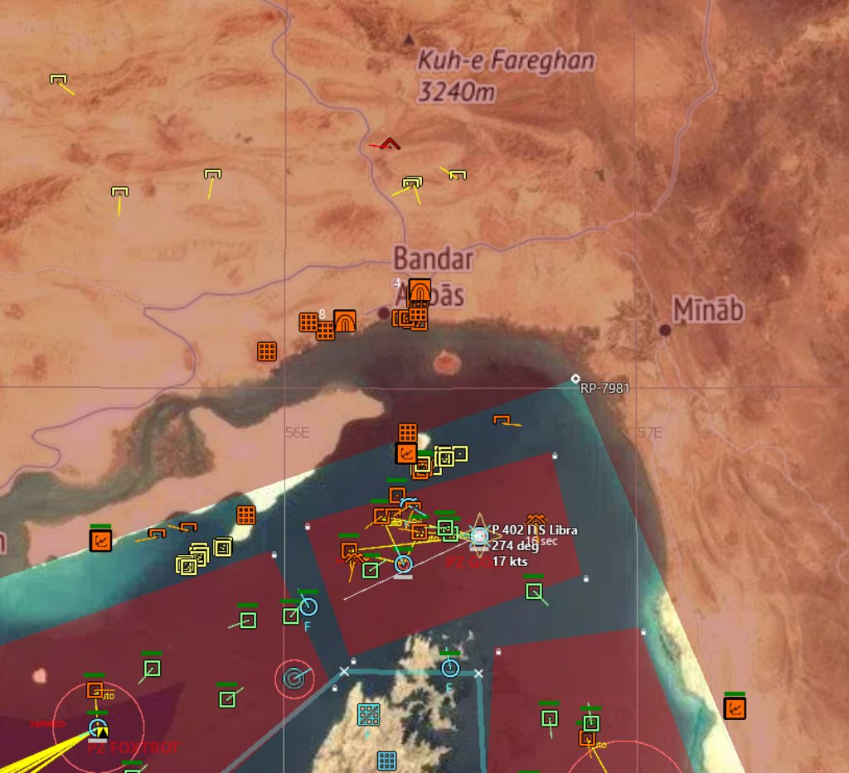

F783 FS Drogou is sinking!!!

FFG 26 USS Gallery is sinking!!!

This is a disaster! Multiple Warsaw attack craft are launching standoff weapons against ships in the gulf and the Iranians seem to have joined the conflict!

An all out war is breaking out! Our allies have started offensive operations against Iran and missiles are flying across the gulf in both directions.

Enemy SAM have activated! The SEAD flights are too take off immediately to deal with Bushehr and Abbas SA-5c 'Gammons'. Air assets in the vicinity may need to retreat back after initial engagements with attack craft until SEAD flights are able to engage.

Message has been sent to SSN 700 Dallas Los Angeles to strike radar infrastructure in Iran with TLAMs and Saratoga task group is to lay out plans for follow up strikes and strike packages.

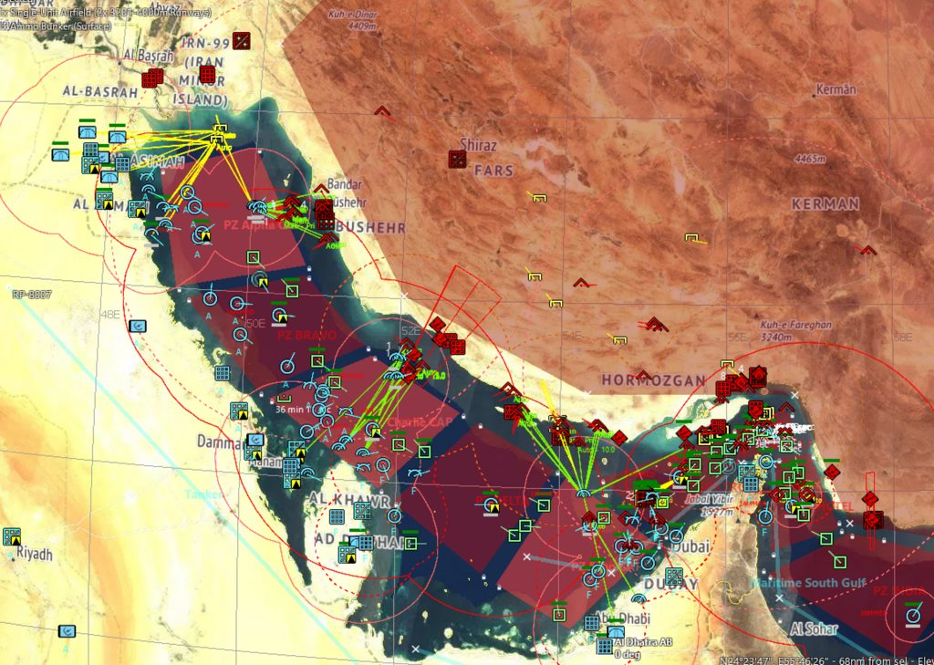

The situation is grim but we are holding as is. Enemy fire of standoff weapons has seized for now. We currently have been having a lack of ready aircraft after the initial engagement but our allies have started to hand over control of local air assets. We now have the UAE and Qatar air force assisting us.

A/C losses so far are

2x AV-8B Harrier II [Night Attack]

1x F/A-18C Hornet

2x F-16CG Blk 40 Falcon

1x Tornado GR.1

Confirmed notable enemy A/C

15x Su-24M Fencer D

1x Tu-16R Badger F

5x F-4D Phantom II

2x F-4E Phantom II

9x F-5F Tiger II

4x MiG-29 Fulcrum A

We have taken several further losses of naval assets.

F 574 ITS Aliseo is damaged after taking standoff weapon fire but operational. He has been engaged south east of Hormuz against enemy naval assets in an ongoing gun battle.

T-AK 3012 USNS Sgt W.R Button is damaged after taking standoff weapon fire. He is still operational and continues

his mission out of the gulf. Albeit slowed down slightly.

F 73 ESPS Cataluna was ambushed by Iranian missile gunboats. They have been dispatched off.

F 81 ESPS Santa Maria is sinking after taking standoff weapon fire in the initial attack.

F 564 ITS Lupo was sunk with standoff weapons as well.

We have received word the the situation within Iran is confused. They are hostile but uncoordinated, something is going in their political structure. They continue to attack neutral shipping in the gulf.

Current priority in tasking orders is to establish air superiority and strike naval assets threatening ships in the gulf and prepare for strikes against Iranian airports hosting A/C. Saratoga CVBG is scrambling fighters and attack craft to gain military superiority in the gulf entrance.

